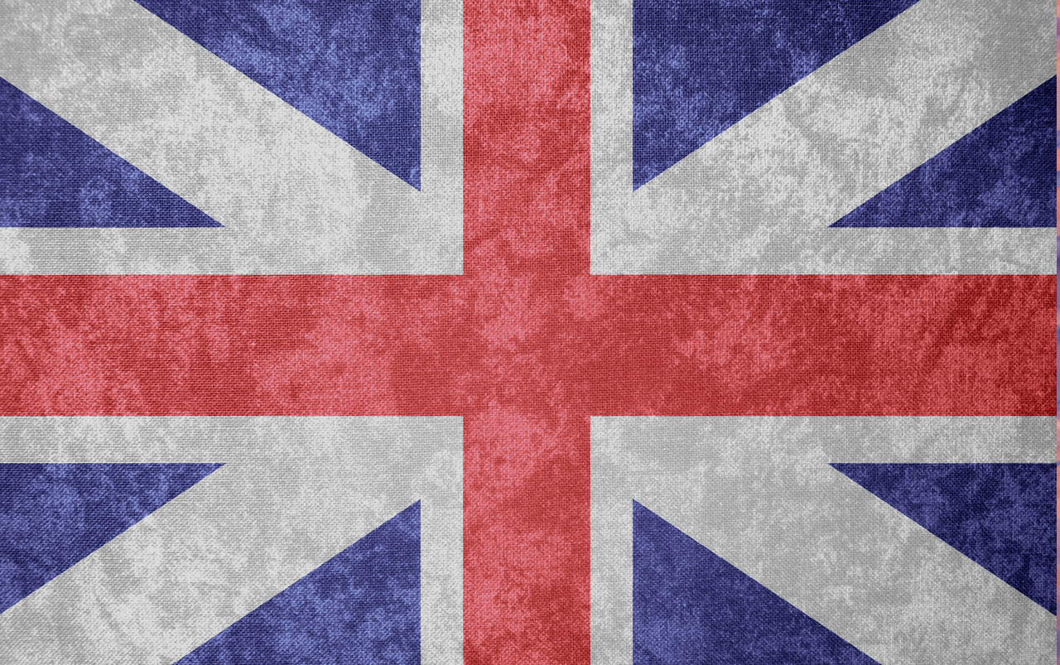
British Values
Picture News 15th-21st February
The Rule of Law
I understand some laws are created in Parliament to help protect animals in our country. As citizens of Britain, we have to follow these rules and laws.

